

OOP Assignment

By-Arun Lal



Sec-E

BSCS(II)

CMS-ID=023-24-0120

OOP Theory Assignment

1. Write a Java program to print the first ‘n’ terms of the Fibonacci series, where n is input by the user (Suggestion: use while loop)

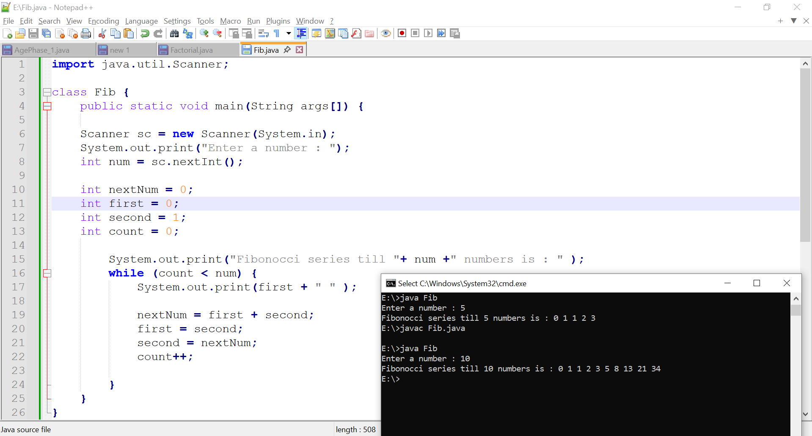

1. Write a Java program to take an integer n as input and print a pyramid pattern of stars (\*) of n rows (Suggestion: use nested loop)

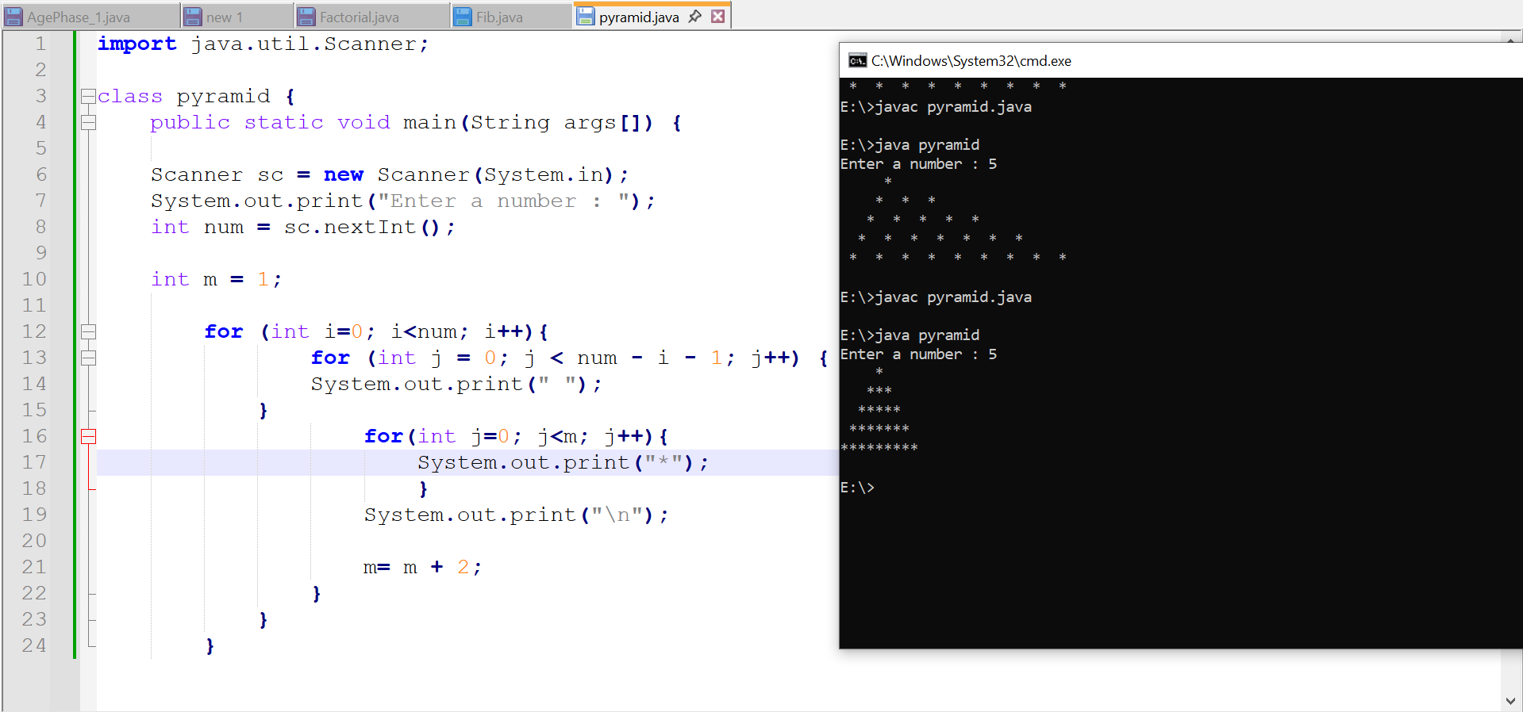

1. Write a Java program that takes an array of numbers and finds the first number that is a multiple of 5. Stop searching when the first multiple is found, take values of array from user (Suggestion: use for and foreach)
   1. Array: {2, 8, 11, 15, 23}// values in array
   2. First multiple of 5: 15// 15 is the 1st multiple or 5 in this array

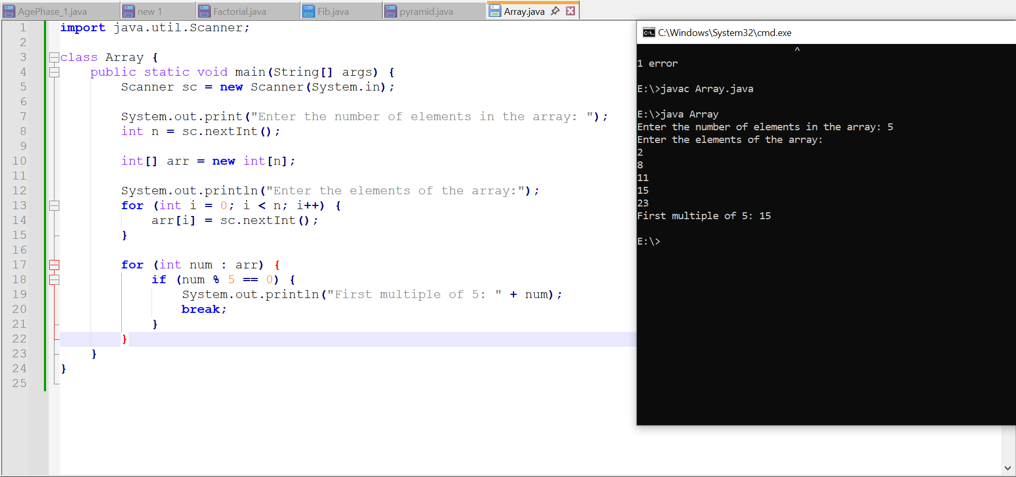

1. Write a Java program that takes 10 numbers from the user. If the number is negative, skip it using continue. Otherwise, add it to the sum.

Hint: Use if (num < 0) continue; inside a loop.

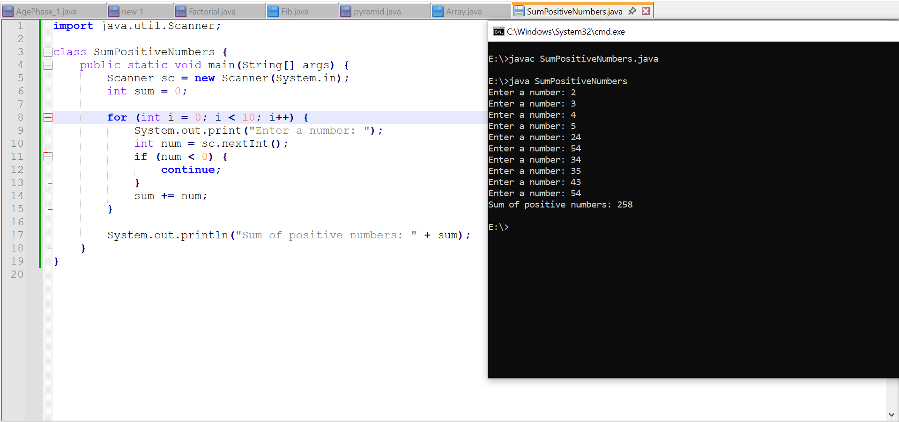

1. Write a Java program that takes a word in String as input and finds the first vowel (a, e, i, o, u) in the word. Stop searching after the first vowel is found, in case there is no vowel print message “No vowels found”.

